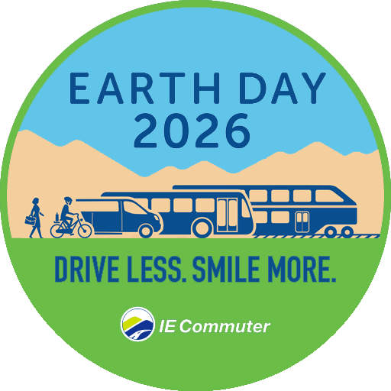
Drive Less. Smile More. Win Big for Earth Day.
This Earth Day, your commute can do more than just get you to work. Help the planet and score awesome prizes when you join IE Commuter’s Earth Day 2026 promotion and turn smart travel choices into chances to win all April long.

Cut back on drive-alone trips and log your trips and telework days with IE Commuter all April long. You’ll reduce your carbon footprint and be entered for a chance to win prizes including Dana Wharf Whale Watching Tickets, Beats Studio Buds, or gift cards to Macy’s or Stater Bros. Every trip you log is an entry, so the more you swap solo driving for greener options, the more chances you have to win.

Ready to make your commute count? Visit IECommuter.org/EarthDay to sign up, check out the full prize list and start celebrating one smart trip at a time. Chat with the IE Commuter team at IECommuter.org or call 1-866-RIDESHARE (866-743-3742) with any questions.

